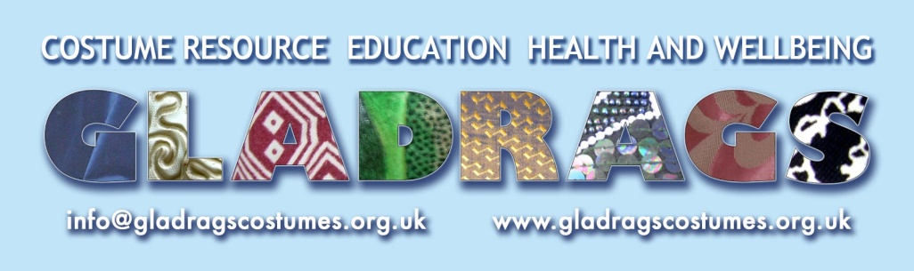

COVID-19 COMMUNITY STORIES

Thank you for sharing your personal account and experiences of life during the age of Coronavirus. These stories will form a free online resource for teachers and community workers seeking to discuss the events of Covid-19 within their schools, community projects and well-being settings. We have an illustrator working on the project and may include some of your approved photos. We will let you know when your story is up on the blog, and be in touch when we are able to produce a printed copy containing some or all of the stories; depending on demand we may need to charge a small fee to certain groups to cover printing costs.

Please use the questions below as a guide but do tell us about your experience in the way that suits you best. You might want to focus on one or two elements that are very specific or unique to your experience. Please be mindful to differentiate between what is your opinion and what is fact. We are looking for written accounts of between 350 and 550 words approximately which we will edit to suit the purpose of the project, whilst staying true to your own words. If you prefer to tell your story verbally, we can arrange an interview with you and write it up. We will then send it to you for your approval. Alternatively you can send us an audio or video story (max length 3 mins; max file size 5MB).

You can email written stories to info@gladragscostumes.org.uk or post to our address below. Audio / video files can be emailed or whatsapped to us on 07940 295623. If you prefer to remain anonymous to the public, you can request this on the consent form below. In this case we would use a made-up name instead. If you would like to send us photos then images that reflect an aspect of your story are particularly helpful.

Your first name (and your parent / carer’s name if applicable):

Your email address - if under 16, this will be your parent / carer’s email address (optional):

How have your circumstances changed during Covid-19 and how have you (personally or collectively in your home) had to adapt e.g. work / home-life / education / activities / contact with others / volunteering?

What have been the challenges (e.g. practical, emotional, educational, home life)?

What positives, if any, have come out of these circumstances?

Could you share a memorable encounter or scenario?

You are welcome to invite others to take part in this project and share this form with them. You could also direct them to www.gladragscostumes.org.uk/lockdownprojects.

Providing your consent
Please put an ‘X’ in the appropriate column for each criteria you are happy to give your consent for in relation to Gladrags’ Covid-19 Stories. If you are under 16, please ask a parent / carer to give consent on your behalf. By putting a cross in these columns, you do so understanding that your / your child’s image or account may be seen now or in the future and that we are not able to guard against third parties copying content from online platforms you have given consent for.

Gladrags project purposes as stated below: | My / my child’s first name | My / my child’s photo, provided by / approved by me | Illustration of me / my child | My / my child’s Covid-19 written account | My / my child’s Covid-19 audio or video story
Online or downloadable resource
Printed resource
Promotion via website
Promotion via social media
Evidencing of the project to Gladrags’ funders
Promotion of the project by Gladrags’ funders

Further Gladrags purposes: | My email address
Staying in touch with me about the project and sharing the completed resource with me.
Staying in touch with me about Gladrags’ charitable work, events and fundraising.
I need / don’t need Gladrags to send me a draft of the edited version of my account before it is published (please circle as applicable).
What are the conditions of consent?
- Without your consent, Gladrags will not use your name, images or text.
- You have the right to amend or withdraw consent at any time and will need to contact Vania Mills on info@gladragscostumes.org.uk to initiate this process.
- Withdrawing your consent will not affect any name, images or text that have been published prior to withdrawal, however, where these files can be easily tracked on our online platforms they will be removed.
For further detail please view our Privacy Notice at www.gladragscostumes.org.uk. If you have any questions regarding this form, please do not hesitate to contact Vania Mills.
Gladrags Community Costume Trust Charity registration Number 1122704
Unit 10, Westergate Business Centre, Westergate Road, Brighton, BN2 4QN.
01273 609184 www.gladragscostumes.org.uk 07940 295623

