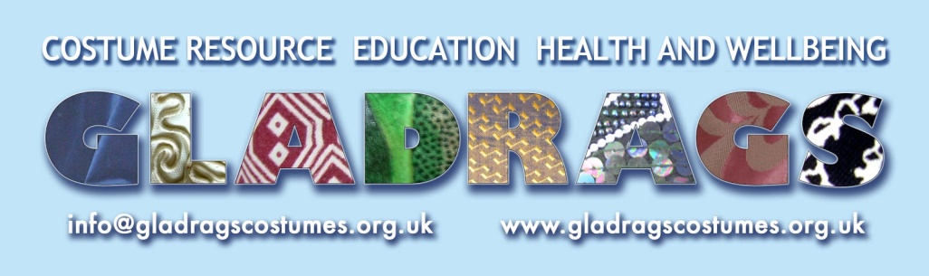

COVID-19 COMMUNITY STORIES

Thank you for sharing your story and experience of of life during the age of Coronavirus. These stories will form a free online resource and a booklet for teachers and people working in the community who will be talking about the events of Covid-19 within their schools, community projects and well-being settings for a long time to come. Please use the questions below to help tell us your story but do tell us more if you want to! On page 2 there is a more detailed set of questions that you can choose from if this is helpful. If you prefer to talk about your experience, we or your parent/carer/teacher can ask you the questions and write it down for you. We will check if you are happy with it before putting it on our website. The third option is to send us an audio or video story (max length 3 mins; max file size 5MB).

We are looking for stories of between 250 and 550 words approximately and we will edit them but we will stay true to your words. Your parent/carer/teacher can email your story to info@gladragscostumes.org.uk or you can post it to our address below. Audio / video files can be emailed or whatsapped to us on 07940 295623. As you are under 16 your parent or carer will need to complete the consent section on page 3 on your behalf where they can also tell us if you and / or they prefer that your name is not mentioned alongside your story, so that it is anonymous. In this case we would use a made-up name instead.

We have an illustrator working on the project and will include some of your photos or pictures, where we have the permission to use them. We will let you know when your story is up on the blog, and be in touch when we are able to produce a printed copy containing some or all of the stories; depending on demand we may need to charge a small fee to certain groups to cover printing costs.

Your first name (and your parent/carer’s name):

Your parent/carer’s email address (optional):

How has life changed for you during Covid-19 (e.g. school work, life at home, contact with your friends, activities, volunteering)? You could also tell us about how it’s been for others in your home.

How have you coped with the changes in what you can and can’t do during Coronavirus?
How has it been being back in school? Meeting with your friends and family?
What have you found hard, if anything?
What has happened that has been positive or even fun?
Can you tell us about a memorable moment?

If you would like to, you could send one or more photos or pictures (e.g. drawing, painting) that help to show what you have told us about.

You are welcome to invite others to take part in this project and share this form with them. You could also direct them to www.gladragscostumes.org.uk/lockdownprojects.
1
HOME
How has life changed for you and your family at home during Coronavirus?
How have these changes made you feel?
Are you parents working and if so how are they doing this? (e.g. Where do they go to work? How do they work from home?)
Have you been able to continue hobbies or clubs and how have you done this? Or- what do you do in your free time?
Have you or your family had help from anywhere?
Have you or your family given help to others?

FRIENDS
How has it been, keeping in touch with your friends / wider family?
If you are able to meet with friends, what do you do together? How do you have fun?
If you still can’t see friends / wider family, please tell us why and how that feels?

SCHOOL WORK
How have you found being back at school?
If it has been boring or hard (sometimes or all the time), why has it been like this?
If it has been fun or easy (sometimes or all the time), why has it been like this?

EVENTS
Has anything particularly fun or special happened that you can tell us about?
Has anything sad or difficult happened that you are happy to tell us about?
Can you tell us about a memorable moment during the summer break or since term started?

CHANGES
How have you coped with the changes in what you can and can’t do during Coronavirus?
What have you most missed about your life before Covid-19 (and lockdown) happened?
What, if anything, has helped you to cope with this?
What have you most enjoyed when there has been an easing of lockdown?
If you have found easing of lockdown hard or worrying, can you tell us about this and why?
If you haven’t told us already, what have been the biggest changes to your life since March 2020?
How have these changes made you feel?
2
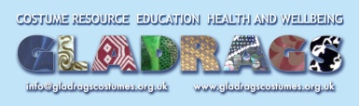
Providing your consent

Dear parent / carer, please put an ‘X’ in the appropriate column for each criteria you are happy to give your consent for in relation to your child’s contributions to our Gladrags’ Covid 19 Stories. By putting a cross in these columns, you do so understanding that your child’s name, image or account may be seen now or in the future and that we are not able to guard against third parties copying content from online platforms you have given consent for.

NAME OF CHILD:

Gladrags project purposes as stated below: | My child’s first name | My child’s photo, provided by / approved by me | An illustration of my child | My child’s Covid-19 story above | My child’s audio or video story | Artwork created by my child
Online or downloadable resource
Printed resource
Promotion via website
Promotion via social media
Evidencing of the project to Gladrags’ funders
Promotion of the project by Gladrags’ funders

Further Gladrags purposes: | My email address
Staying in touch with me about the project and sharing the completed resource with me.
Staying in touch with me about Gladrags’ charitable work, events and fundraising.

I need / don’t need Gladrags to send me a draft of the edited version of my account before it is published (please circle as applicable).

- What are the conditions of consent?
- Without your consent, Gladrags will not use your name, images or text.
- You have the right to amend or withdraw consent at any time and will need to contact Vania Mills on info@gladragscostumes.org.uk to initiate this process.
- Withdrawing your consent will not affect any name, images or text that have been published prior to withdrawal, however, where these files can be easily tracked on our online platforms they will be removed.
For further detail please view our Privacy Notice at www.gladragscostumes.org.uk. If you have any questions regarding this form, please do not hesitate to contact Vania Mills.
Gladrags Community Costume Trust Charity registration Number 1122704
Unit 10, Westergate Business Centre, Westergate Road, Brighton, BN2 4QN.
01273 609184 www.gladragscostumes.org.uk 07940 295623

